Give the Gift of Health & Wealth…
Holiday Gift Ideas for Everyone in Your Life!



Athletic Types:
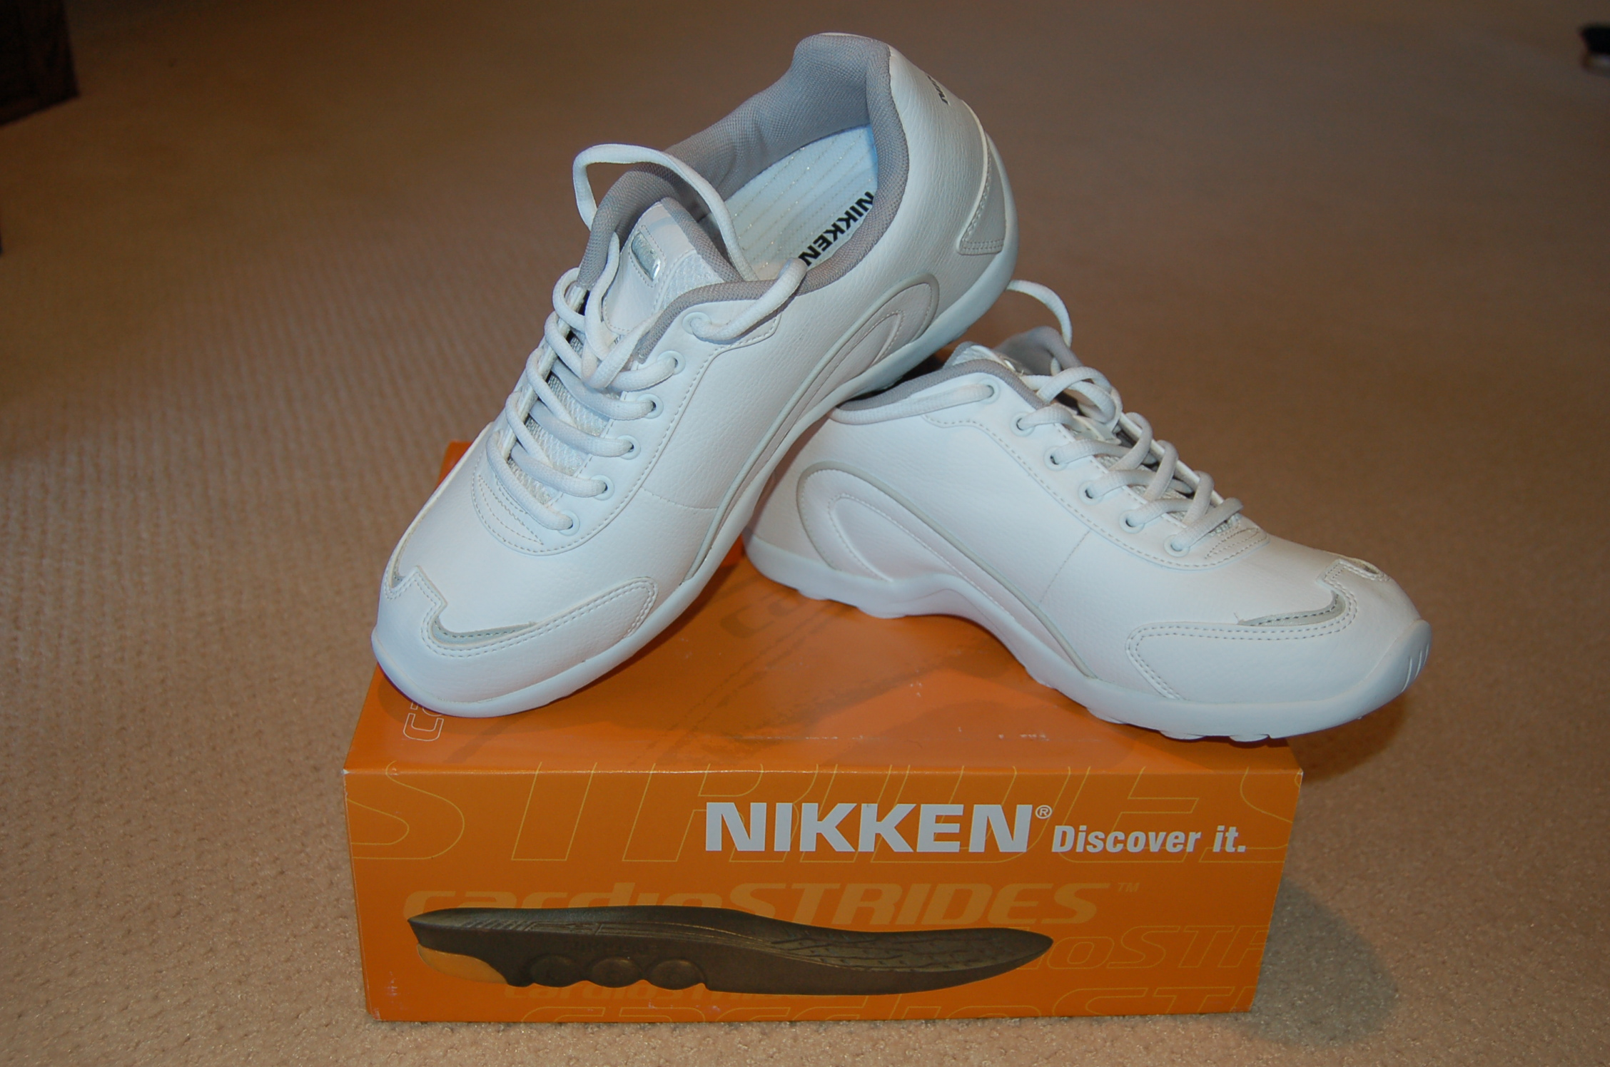
Wraps: Neck, Shoulder, Hand, Wrist,
Elbow, Thigh, Ankle, Back
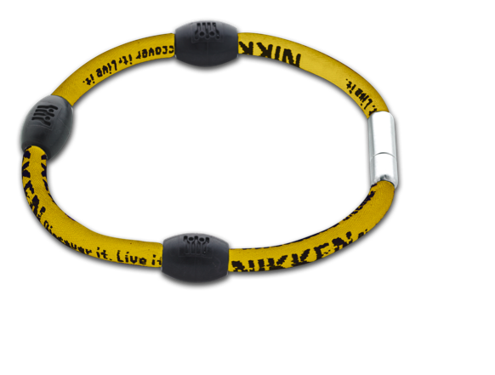
Shoe inserts: MagSteps or Strides
Sport Socks, Sport Bracelets
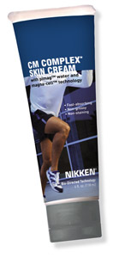
Joint Formula & CM Cream
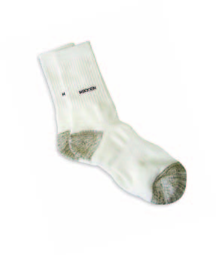

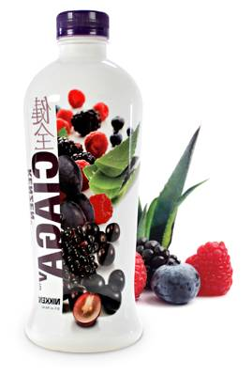
Healthy Living:
Nutrition: Organic Nutritionals,
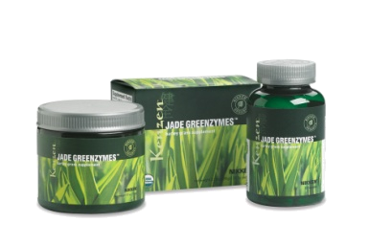
Shower System, Water/Air filtration
Keeps your body working at its optimum.
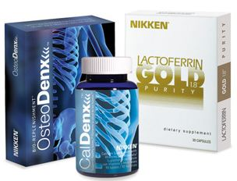
- Bone Health
- Anti-oxidants
- Ph Balance
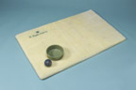
Pet Products:
Pet pads & nutritionals
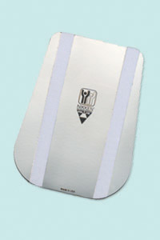

Sitting at a Computer?
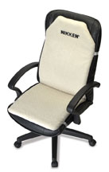
KenkoSeat, Wrist wrap, Back Flex,
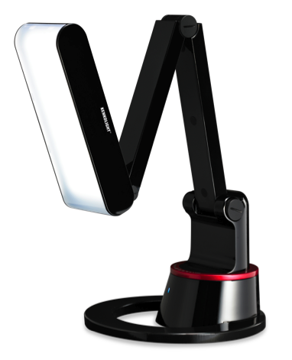
Bracelets, KenkoLight

Aches & Discomforts?
MagSteps/ Strides,KenkoSeat
Joint Formula & CM Cream
KenkoWave, Biaxial PowerMag, MagBoys, MagCreator, Kenko Power
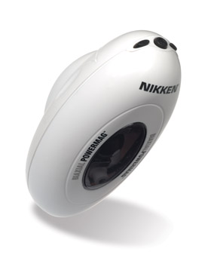
Patches


Accessories & Jewelry:
Women: Necklaces, Bracelets, Sport Socks
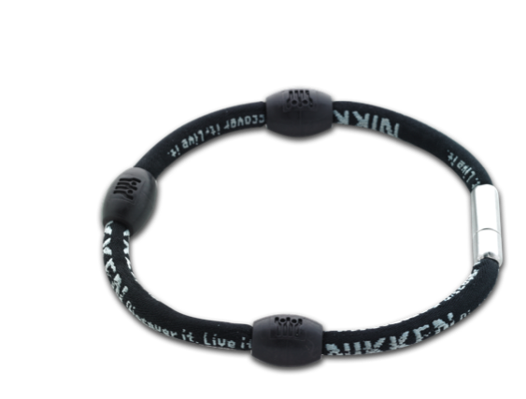
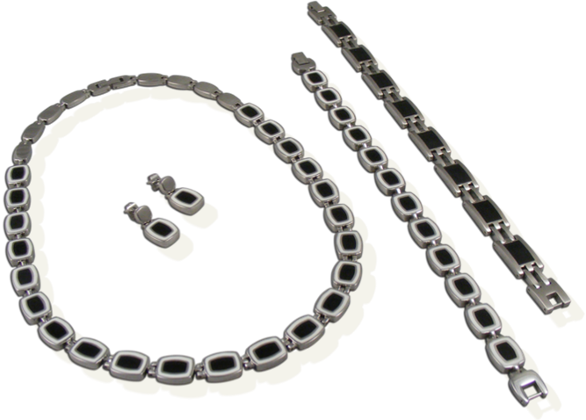
Men: Neck Chain, Bracelet, Sport Socks

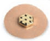

Power Patch!
The Nikken Business Opportunity

Become a Consultant for $35 plus tax & shipping…receive a 20% discount & buy at wholesale. Share Nikken with others to Earn EXTRA Cash or even a Car!

YOUR NAME HERE
PHONE # HERE
YOUR WEB SITE HERE
E-MAIL HERE

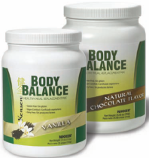
Shed Holiday Pounds:
Organic Meal Replacement,
CardioStrides,
PiMag Water,
Intestinal Health

Trouble Sleeping? State of the Art Sleep Solutions
Enhanced Magnetic RAM
NEW Naturest Topper & Pillow with RAM technology!
Technology Naturest Mattress
Topper & Custom pillow,
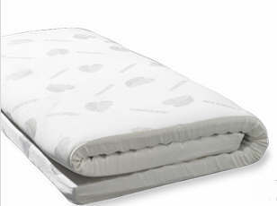
Infrared Comforters, Sleep Mask,
Travel Comforter
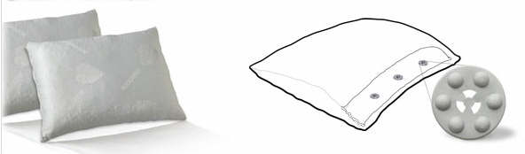

Skin Care:
True Elements™ Swiss Organic Skin Care products are made from the flowers, vines and herbs that grow in the Valaisan Mountains of the Swiss Alps. They are certified organic by Ecocert — a distinction that can be claimed by few skin care products, even many with “organic” on the label.
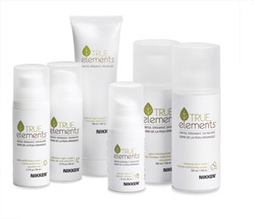

Jet Lag or Long Drives?
KenkoSeat , Neck Wrap,
Necklace, Magboys

Energy Savers:
Magna Charger/Gasoline
Sleep Quilts/Utility Bills

There are so many people who are suffering today.
Why not give the gift of health & wellness! Give someone you love, a gift that will make a positive difference in their life this year. They will thank you many times over in the years to come for helping them improve their Quality of Life!

